2020-0701 IST 707 Data Analytics

Homework #3

Sathish Kumar Rajendiran

2020-07-24

Table of Contents

Task Summary 2

Data set creation using Twitter API 2

Data Preprocessing 5

Association Rule Mining 8

Other Visualizations 14

Summary 16

Glossary 17

## **Task Summary**

Perform Association Rule mining on Twitter API feeds. Task includes (but not limited to),

1. Dataset Creation using Twitter API
   1. Setup developer account
   2. Authentication
   3. Data extraction on select keywords search
2. Data preprocessing
   1. Data Type conversion
   2. Stop words removal
   3. Replace tweet words having digits
   4. Write to file
3. Association Rule mining
   1. Create transaction set
   2. Item set creation
   3. Create rules
   4. Apply rules based on Confidence and Support Parameters
   5. Remove redundant rules
   6. Inspect and plot graph on top rules
4. Visualization & Other Analytics
   1. Visualize frequent/ interesting words from tweets
   2. Perform Sentiment Analysis using “nrc” lexicon library
   3. Word cloud
5. Summary
   1. What’s the story(stories) in this data? Discuss support, confidence and lift parameters and their impact on the association rule.

## **Data set creation using Twitter API**

In order to perform basket analysis, first step is to setup a developer account with Twitter. It involves the following steps,

1. Setup developer account
2. Create developer account via <https://developer.twitter.com/en>
3. Complete access request form by submitting a justification on why access being requested. Sample quote below,

“Master’s in applied data science student of Prof. Jeremy Bolton from Syracuse university is exploring unstructured data to perform basket analysis/association rule mining with twitter feeds. Hence, access to twitter API is requested.”

1. Once developer account is activated, create an app and generate authentication token. This includes 4 key values,
   1. Consumer Key
   2. Consumer Secret
   3. Access Secret
   4. Access token

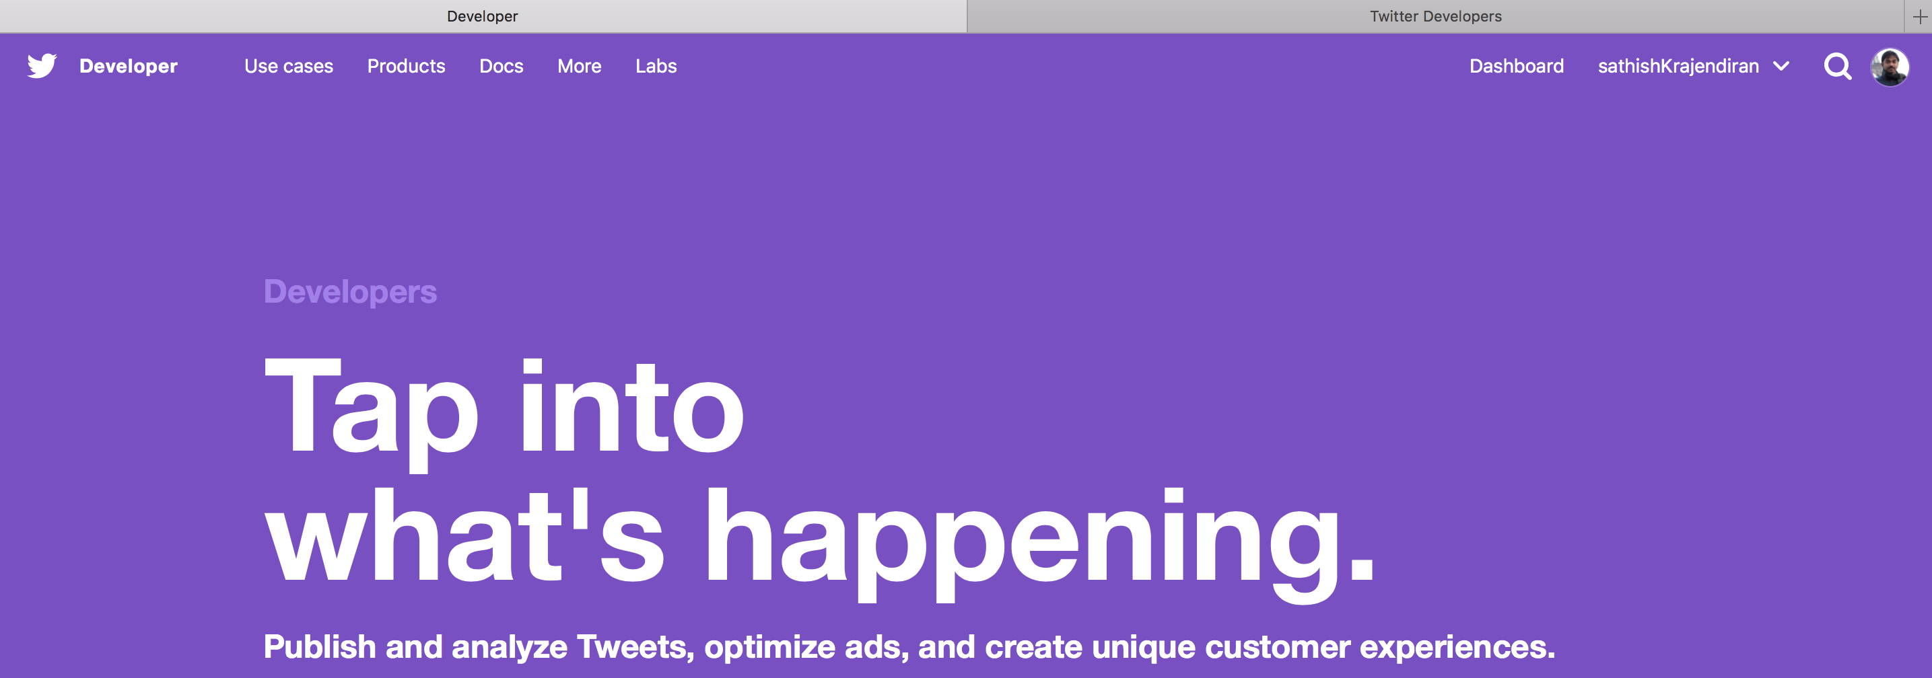

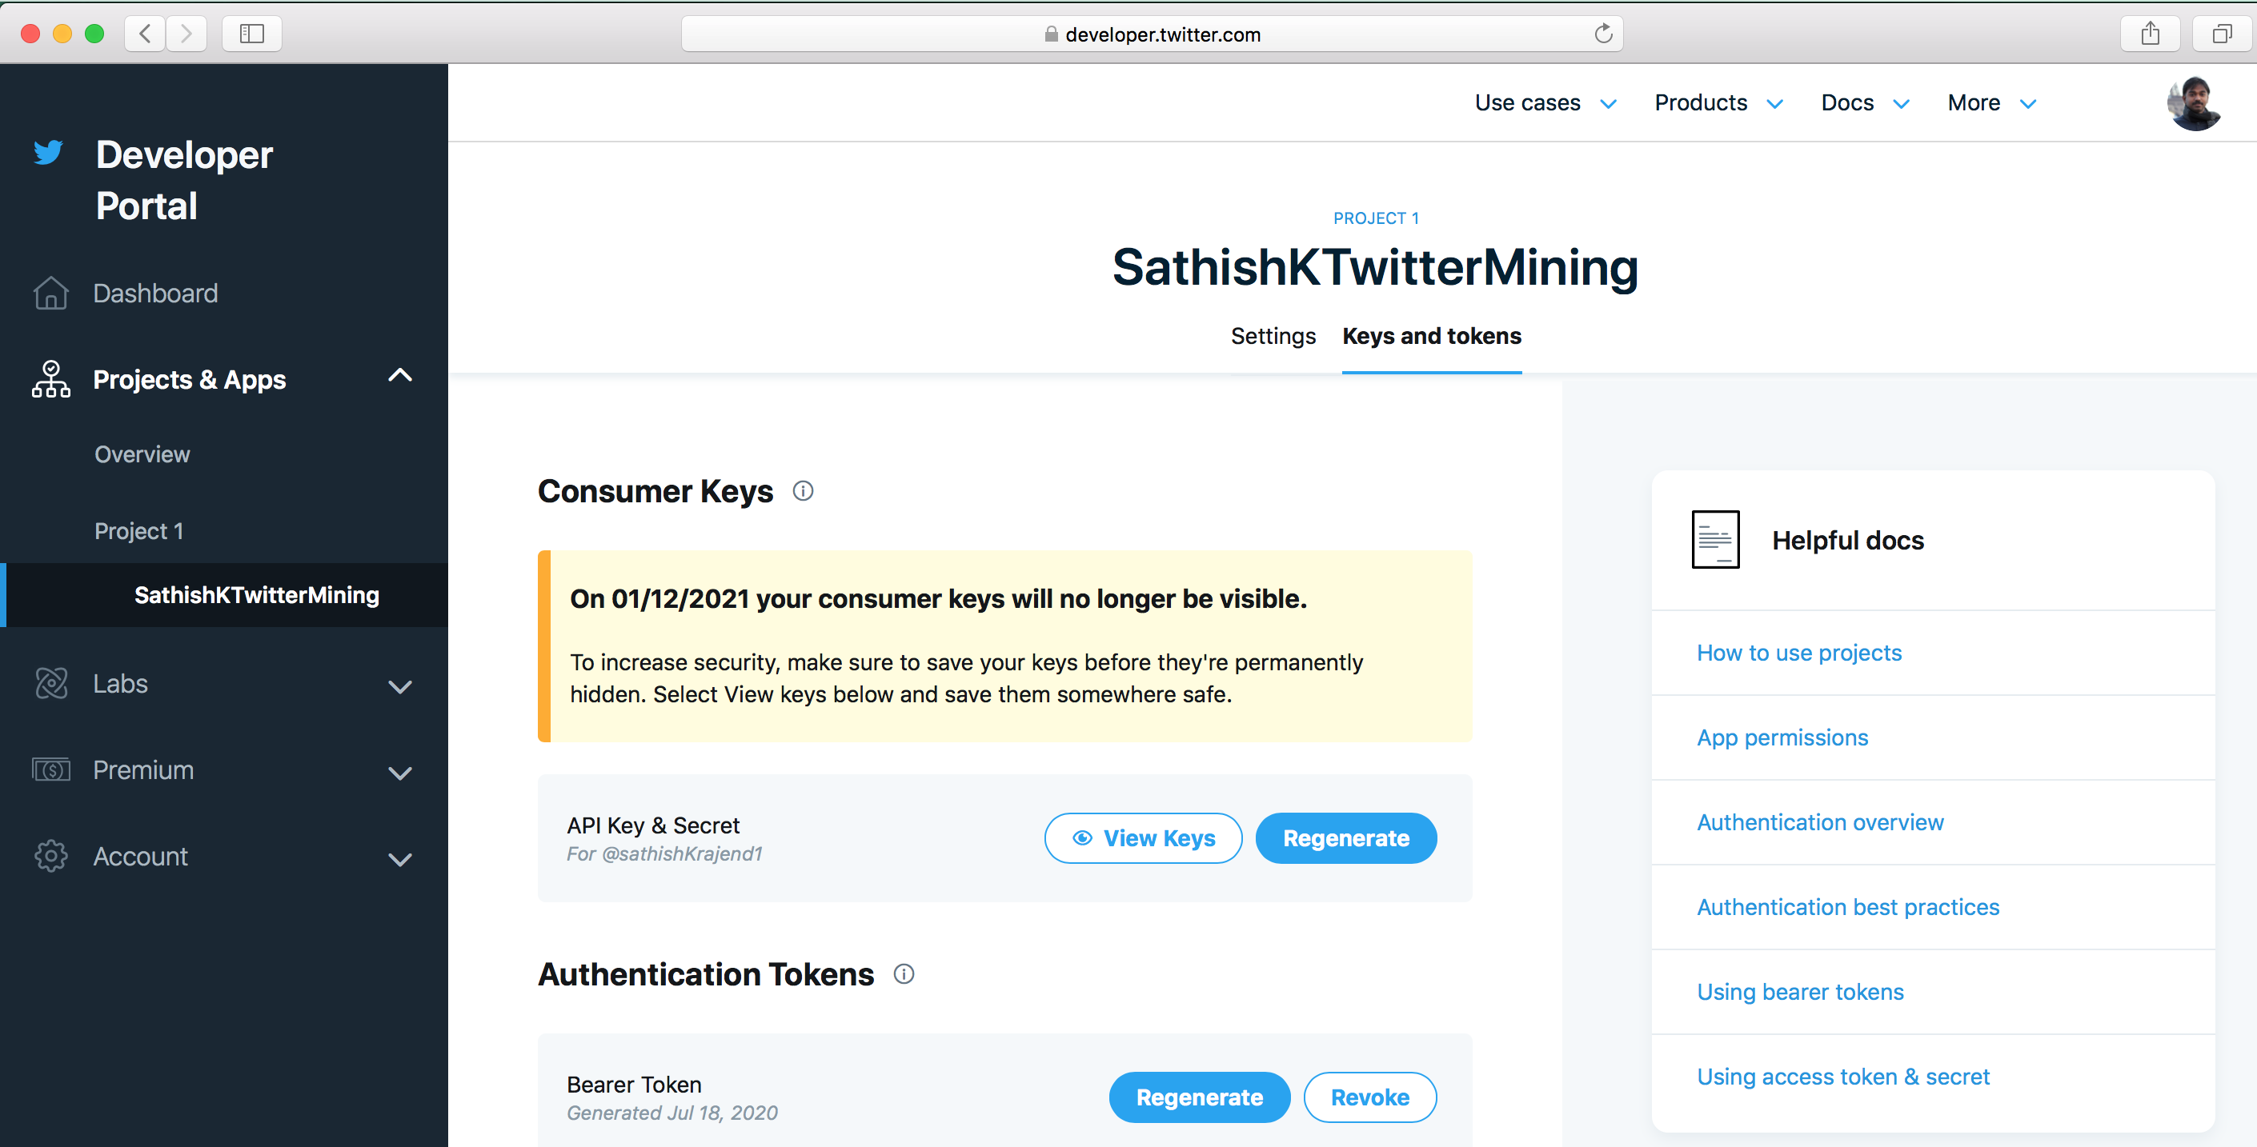

1. Authentication

Lets, authenticate through RStudio using the TwitterAPI keys,

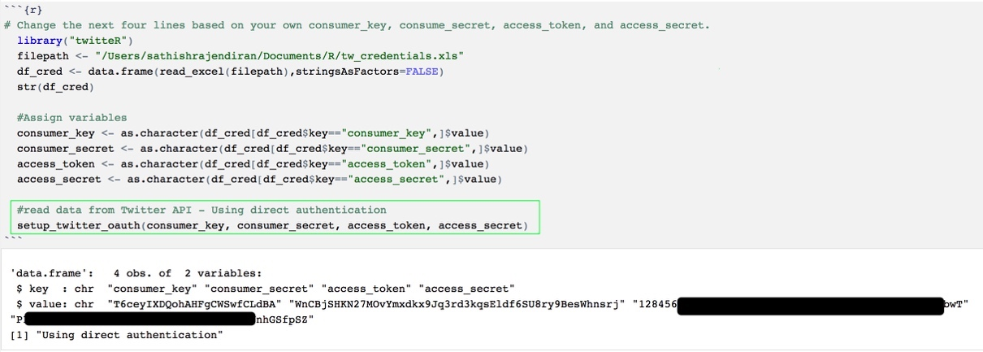

1. Data extraction on select keywords search

As the connection is successful, lets submit a search request with keyword as “covid+retail” to fetch tweets. Other parameters including,

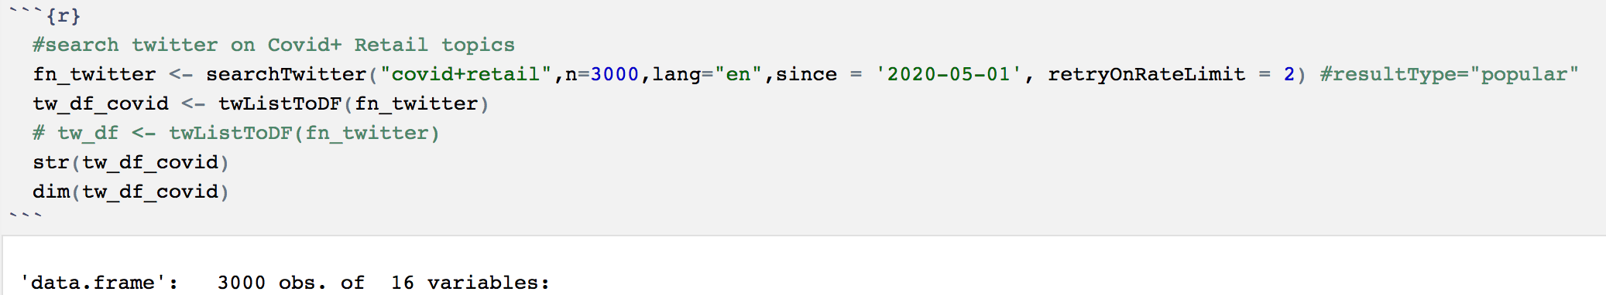

searchTwitter ("covid + retail", n=3000, lang="en", since = '2020-05-01, retryOnRateLimit = 2)

n= 3000 (number of tweets)

lang=” en” (English)

since= ‘2020-05-01’ (date since tweets from)

“covid+retail” – search keyword

API call returns, 16 fields and the result has been moved to a data frame for further processing.

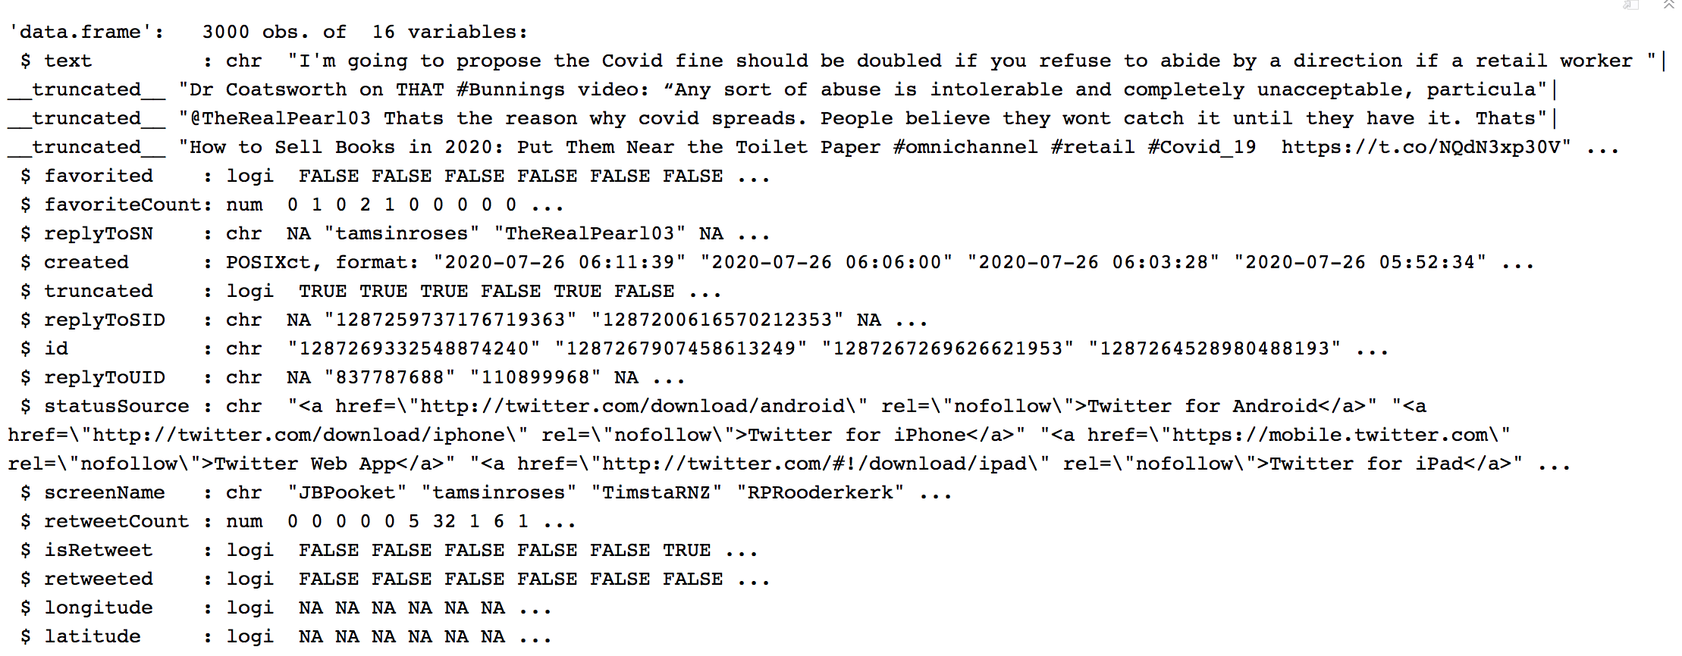

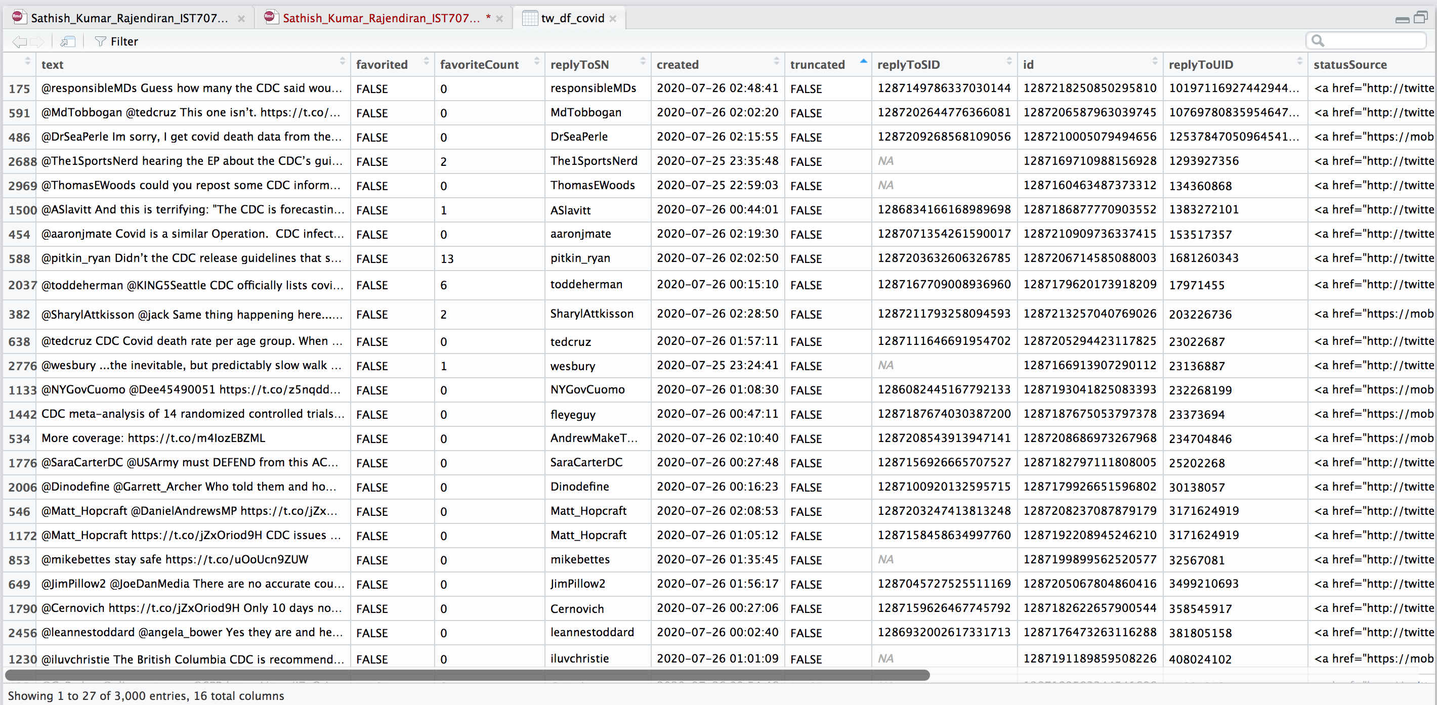

## **Data Preprocessing**

Next step is to prepare the data for basket analysis. Preprocessing include the following steps,

Tokenization

As part of pre-processing, each tweet is recorded as transaction and every word has to be split to tokens. Simply, data frame is looped through each cell and the result is copied to csv file.in this process, common stop words from English along with special words from twitter feeds such as "en", "https", "t.co", "rt", "amp", "the", "of" are also removed. All words are converted into lowercase, punctuations, numeric values are stripped as well.

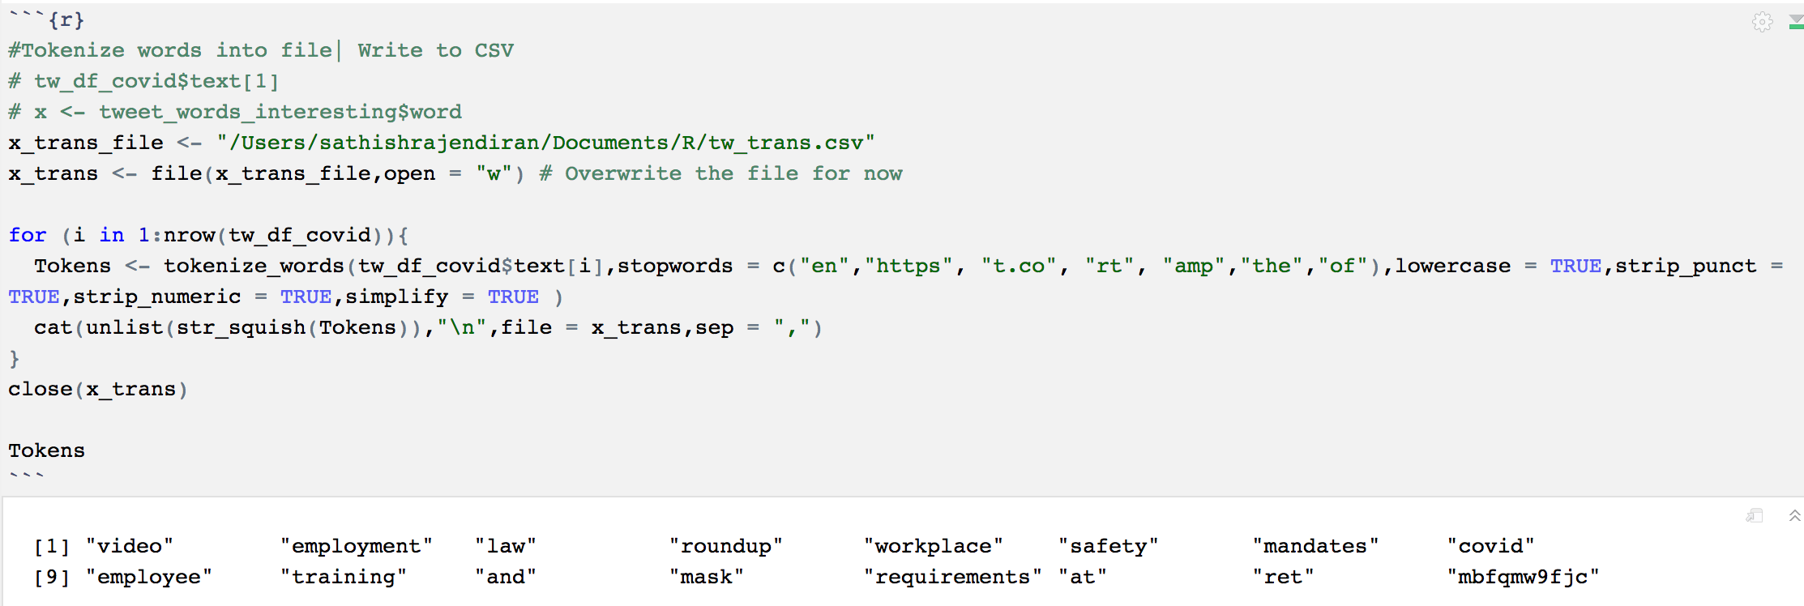

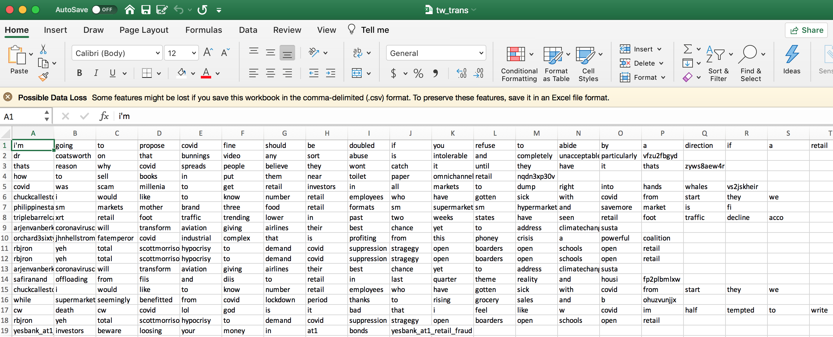

However, this data is still raw and not ready for analysis yet. As part of cleaning, csv file is imported into data frame again. Once, the values are read successfully, all columns are converted into “Characters”, additional stop words such as ("a", "o", "i) are removed. In addition, every word having digits are replaced with "" (empty) string then eventually replaced with blank values in the data frame. Lastly, data frame value is exported to csv file.

Picture below showing spread of words across 24 columns.

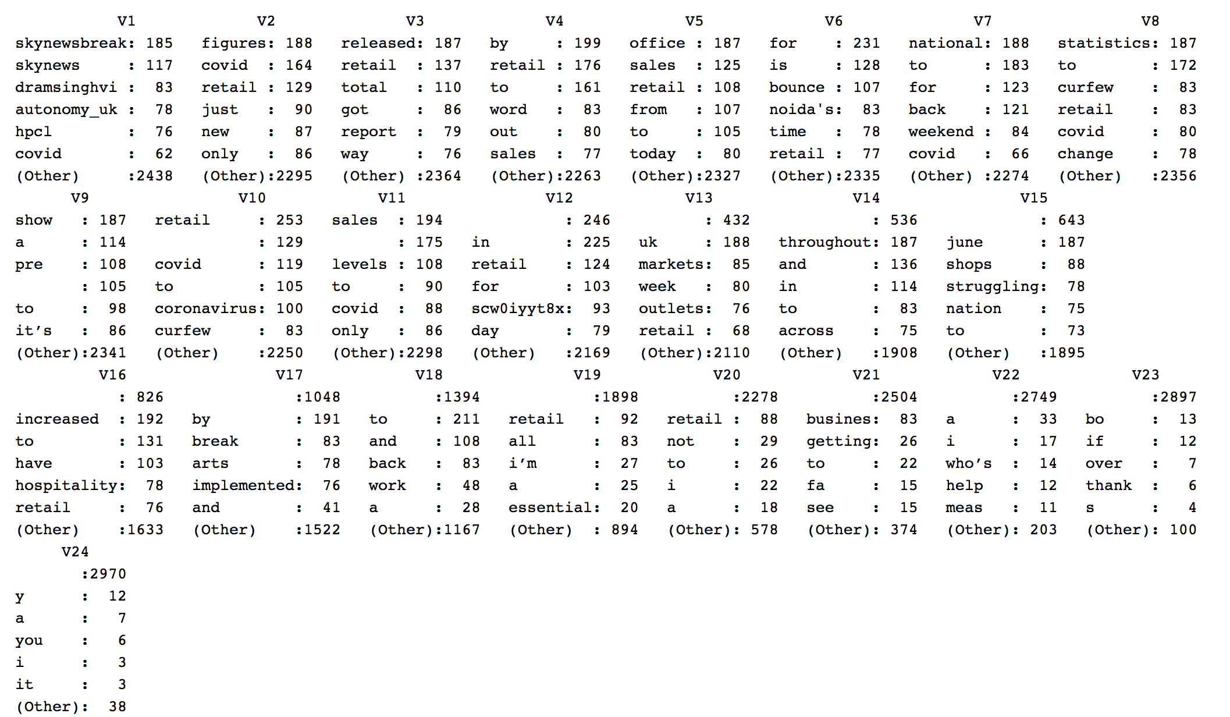

Picture below showing R Script for scrubbing the data

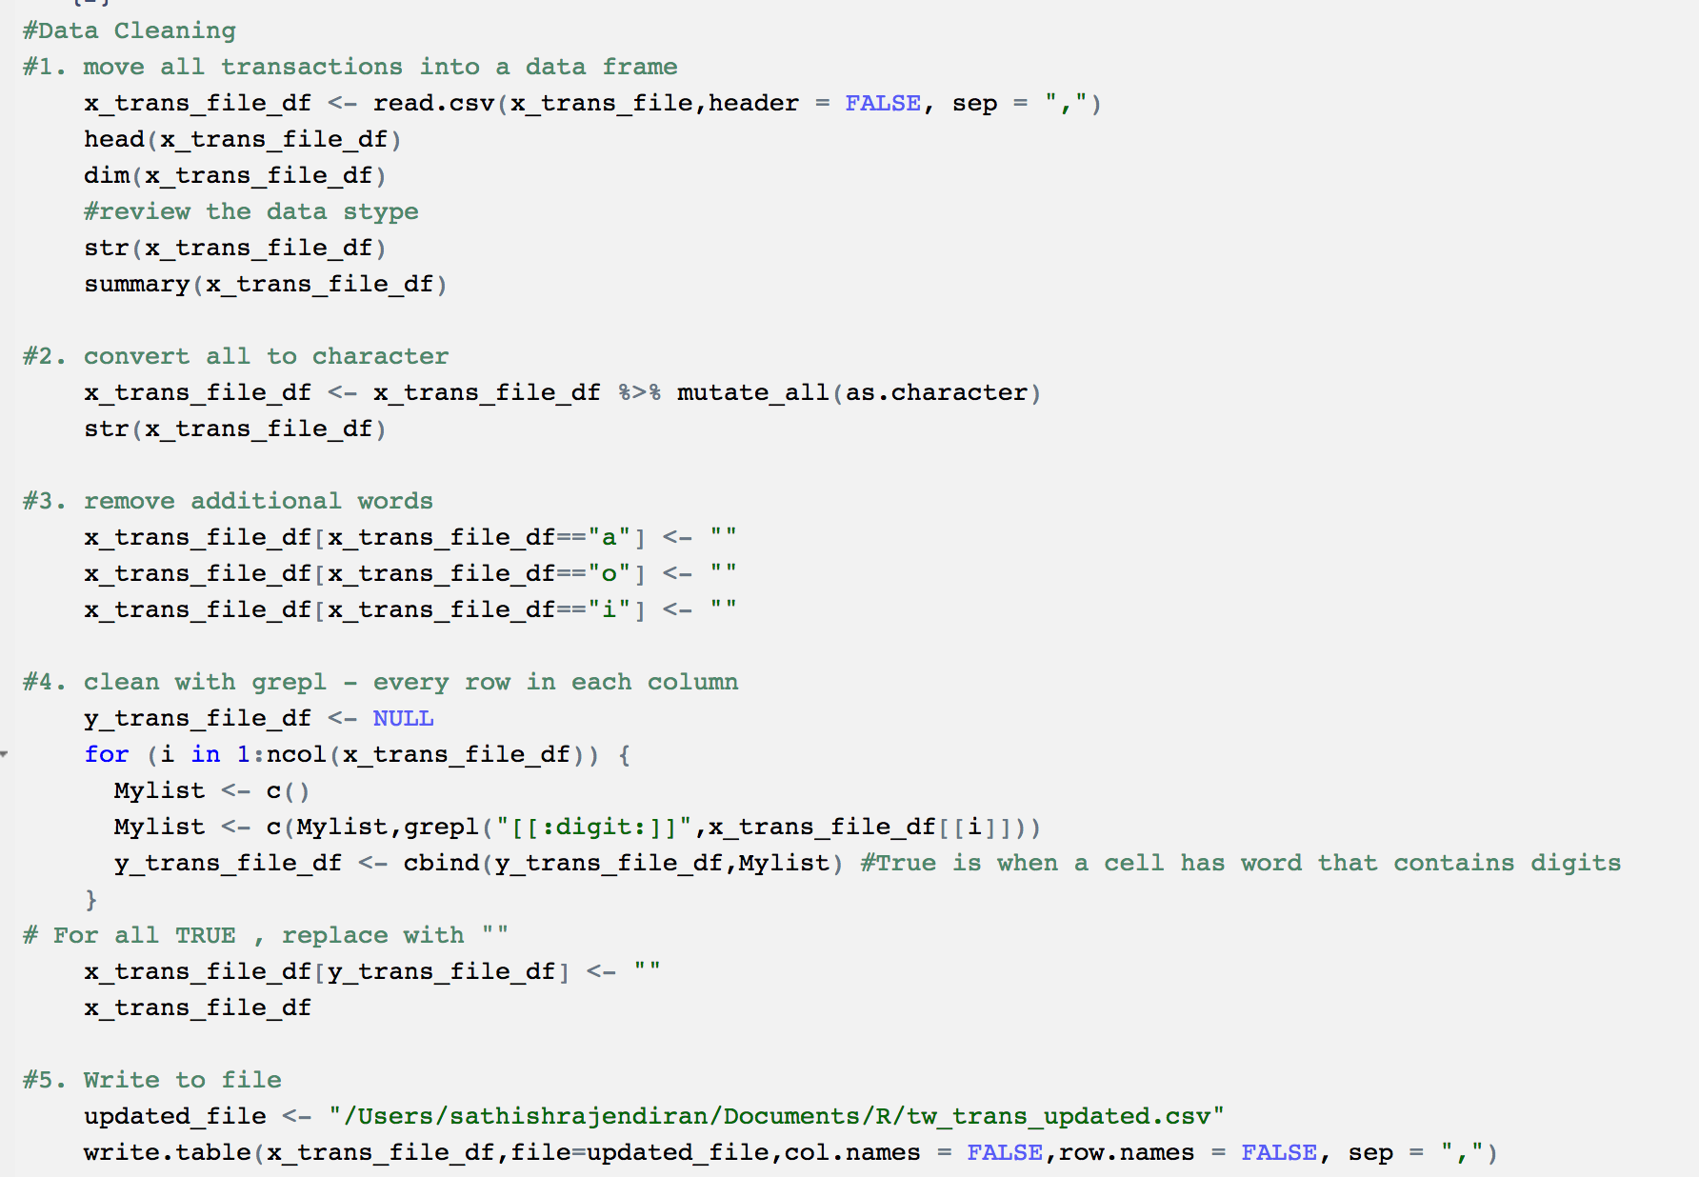

Picture below showing - data frame after data type conversion.

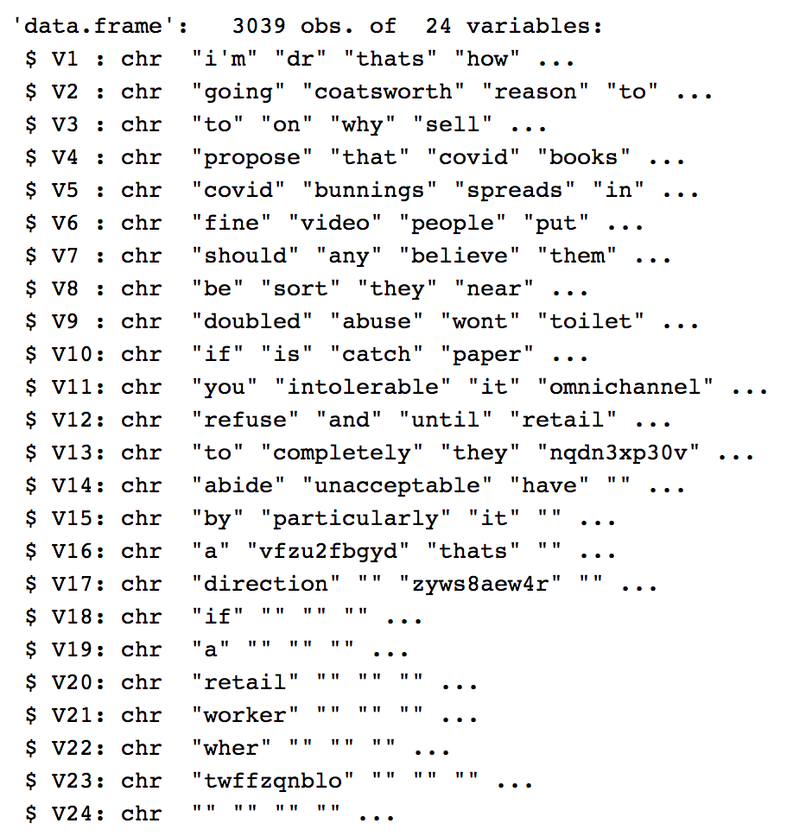

Picture below showing - data frame after scrubbing

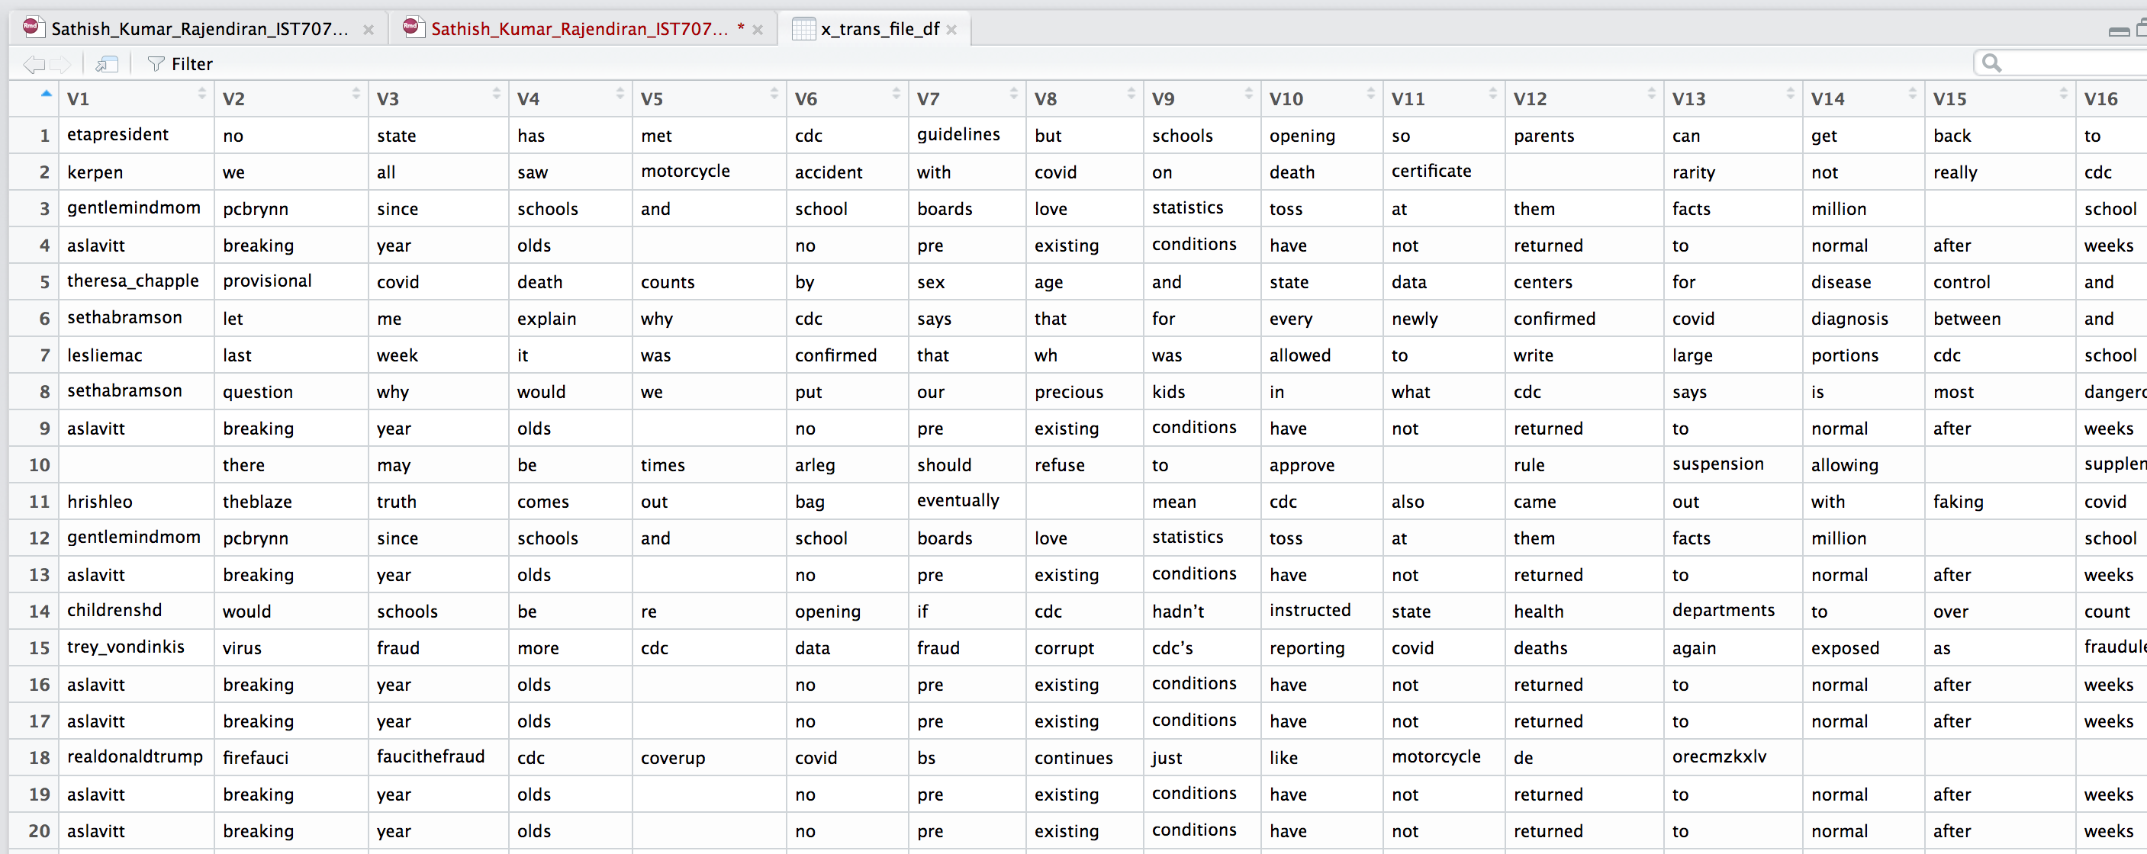

Picture below showing – output csv after scrubbing

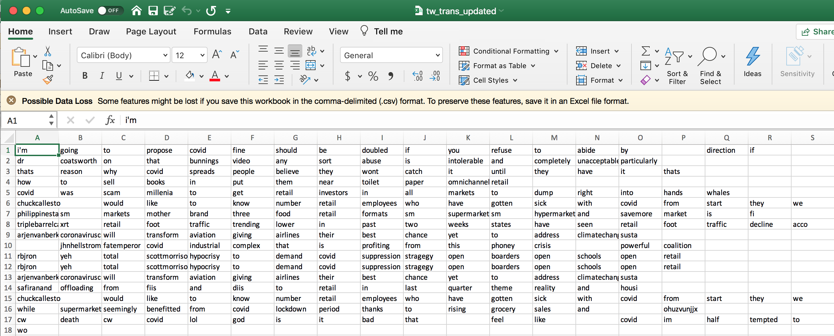

## **Association Rule Mining**

Preprocessing complete. Next step is to prepare the data for basket analysis. It involves, creation of transaction, itemset, association rule creation using apriori algorithm, remove redundancy

Transaction creation using basket analysis returning 3039 transactions (number of rows/tweets from data frame) and 5773 items (columns).

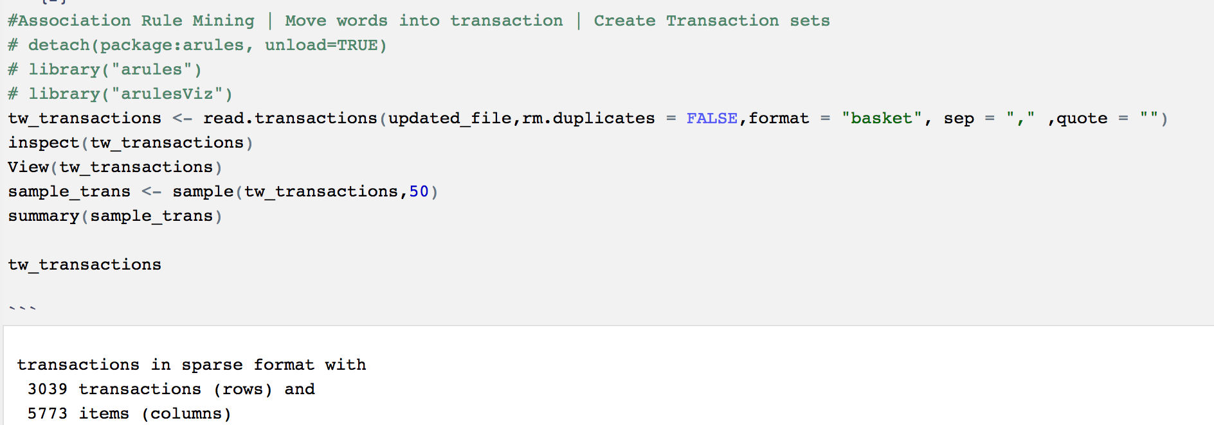

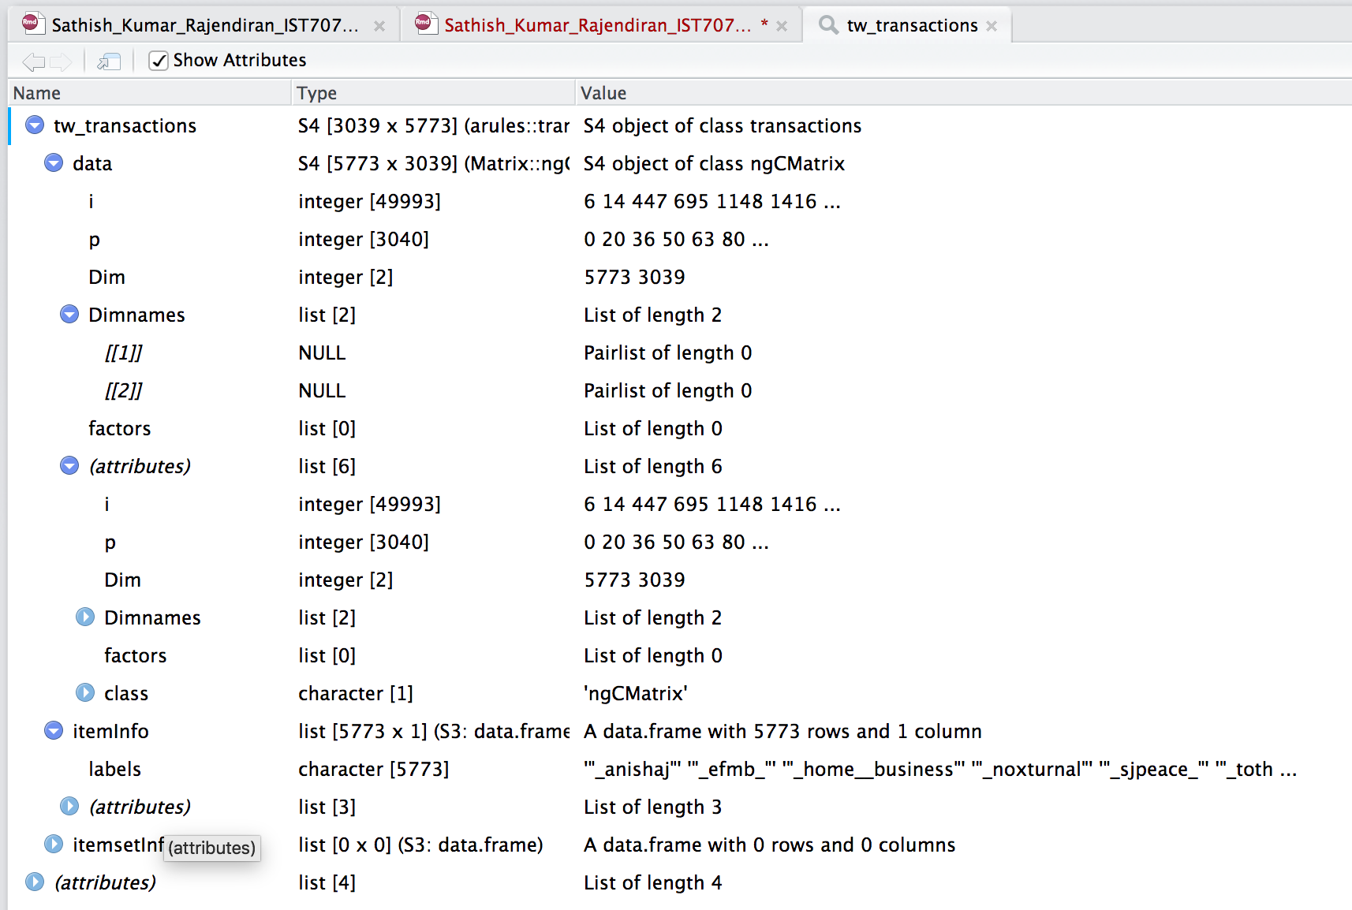

Picture below, showing top 3 out of 3039 transactions above.

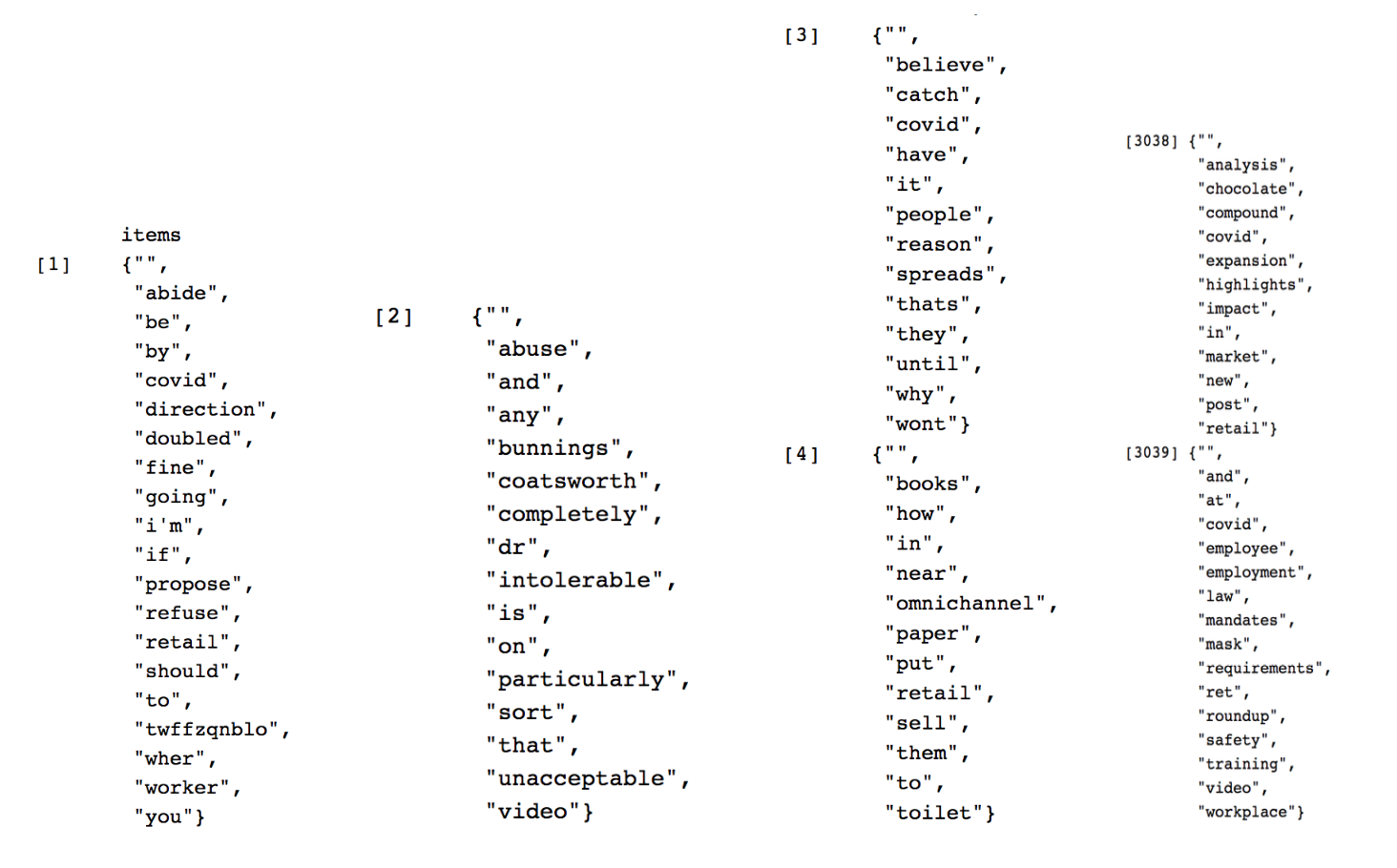

Apriori Rule Creation:

Next step is the most awaited in this exercise – “Apriori rule creation”.Setup parameters as below to generate association rules. Remember, support/confidence and minlen values can be changed to try other rule combinations.

transaction: tw_transactions

support value: 0.0125 ( as the number of transactions >3000)

confidence: 0.8 ( recommended confidence range for stronger correlation)

minlen: keep the number of itemset items to minimum 2

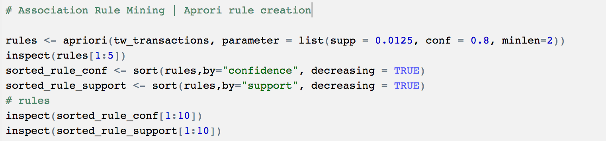

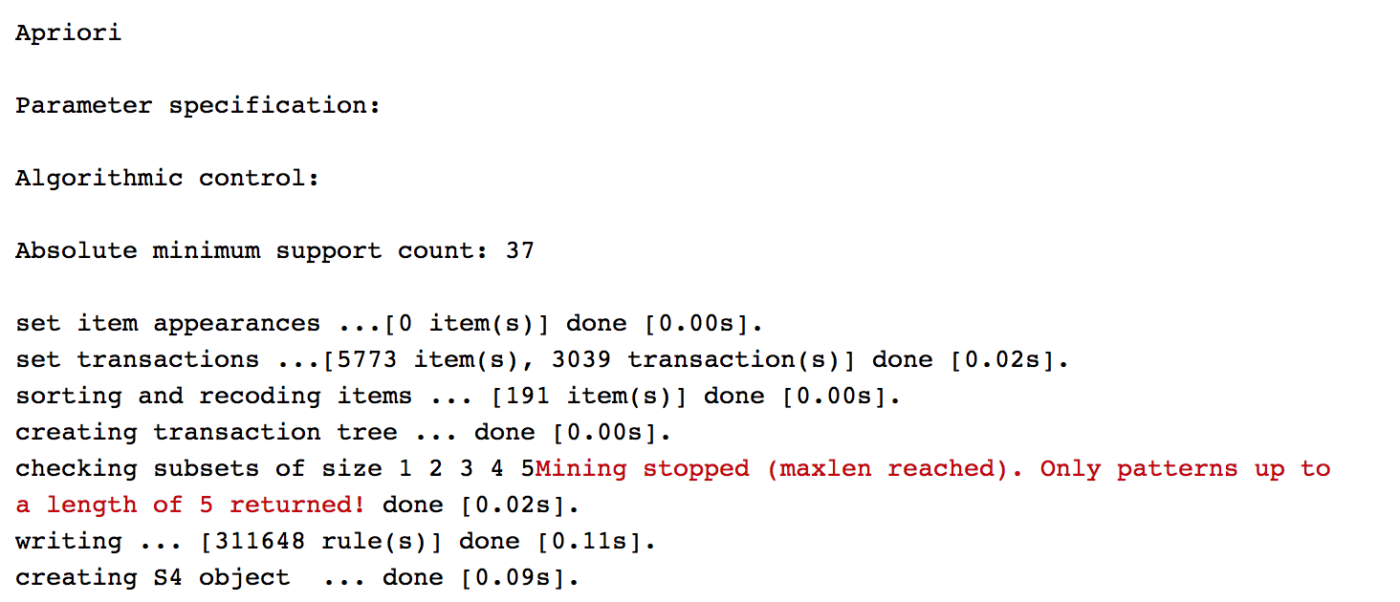

However, its likely that there could be duplicate/redundant rules as below, having simply lhs and rhs changes side respectively in the equation.



In order to effectively, rule out redundant rules run the script below.Reduntant rules, not only add overhead to calculation but also reduces the efficiency of the process. Ruling out 30 to 40% of reduntant rules improves the analysis by simply ignoring them.

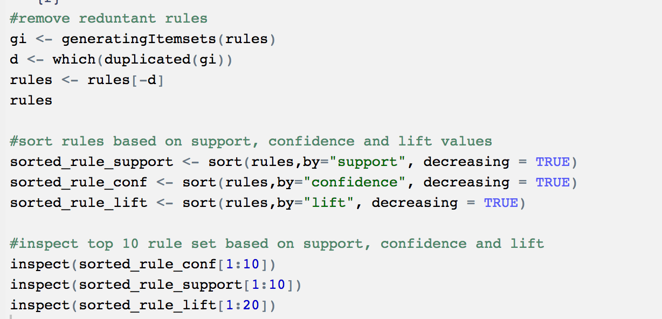

After , eliminating the redundant rules from apriori algorithm, top 20 rules based on highest “Lift” values shown below,

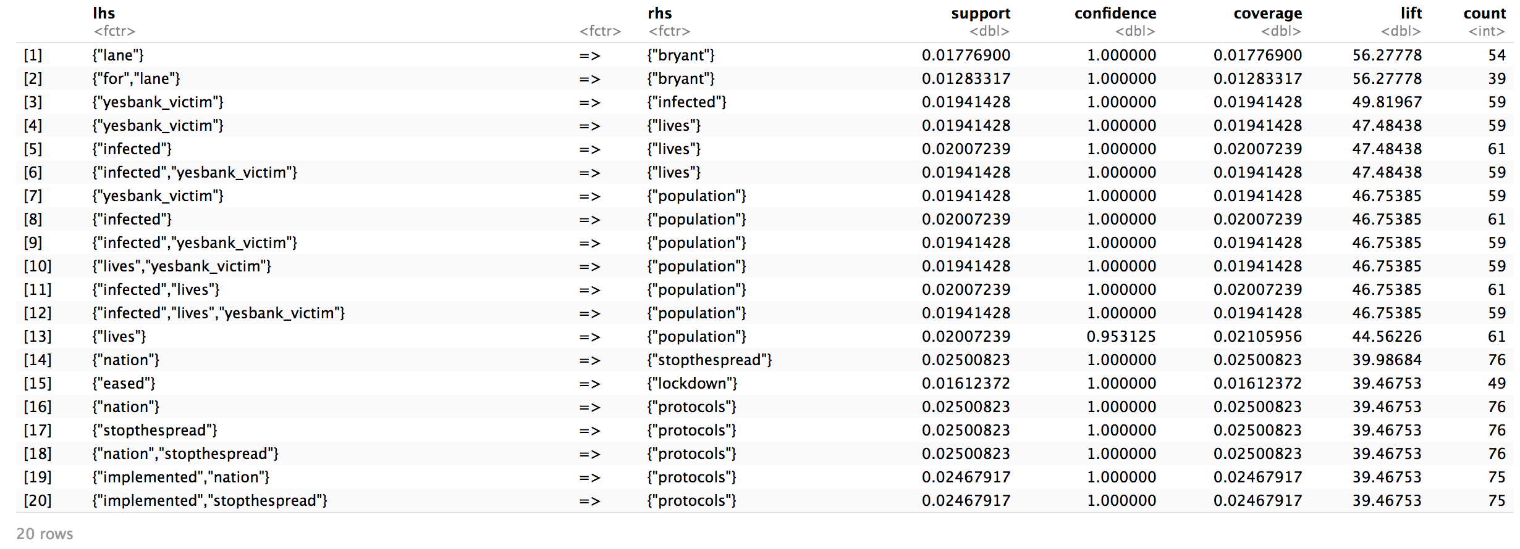

Plot the top 20 rules using htmlwidget for an interactive analysis.



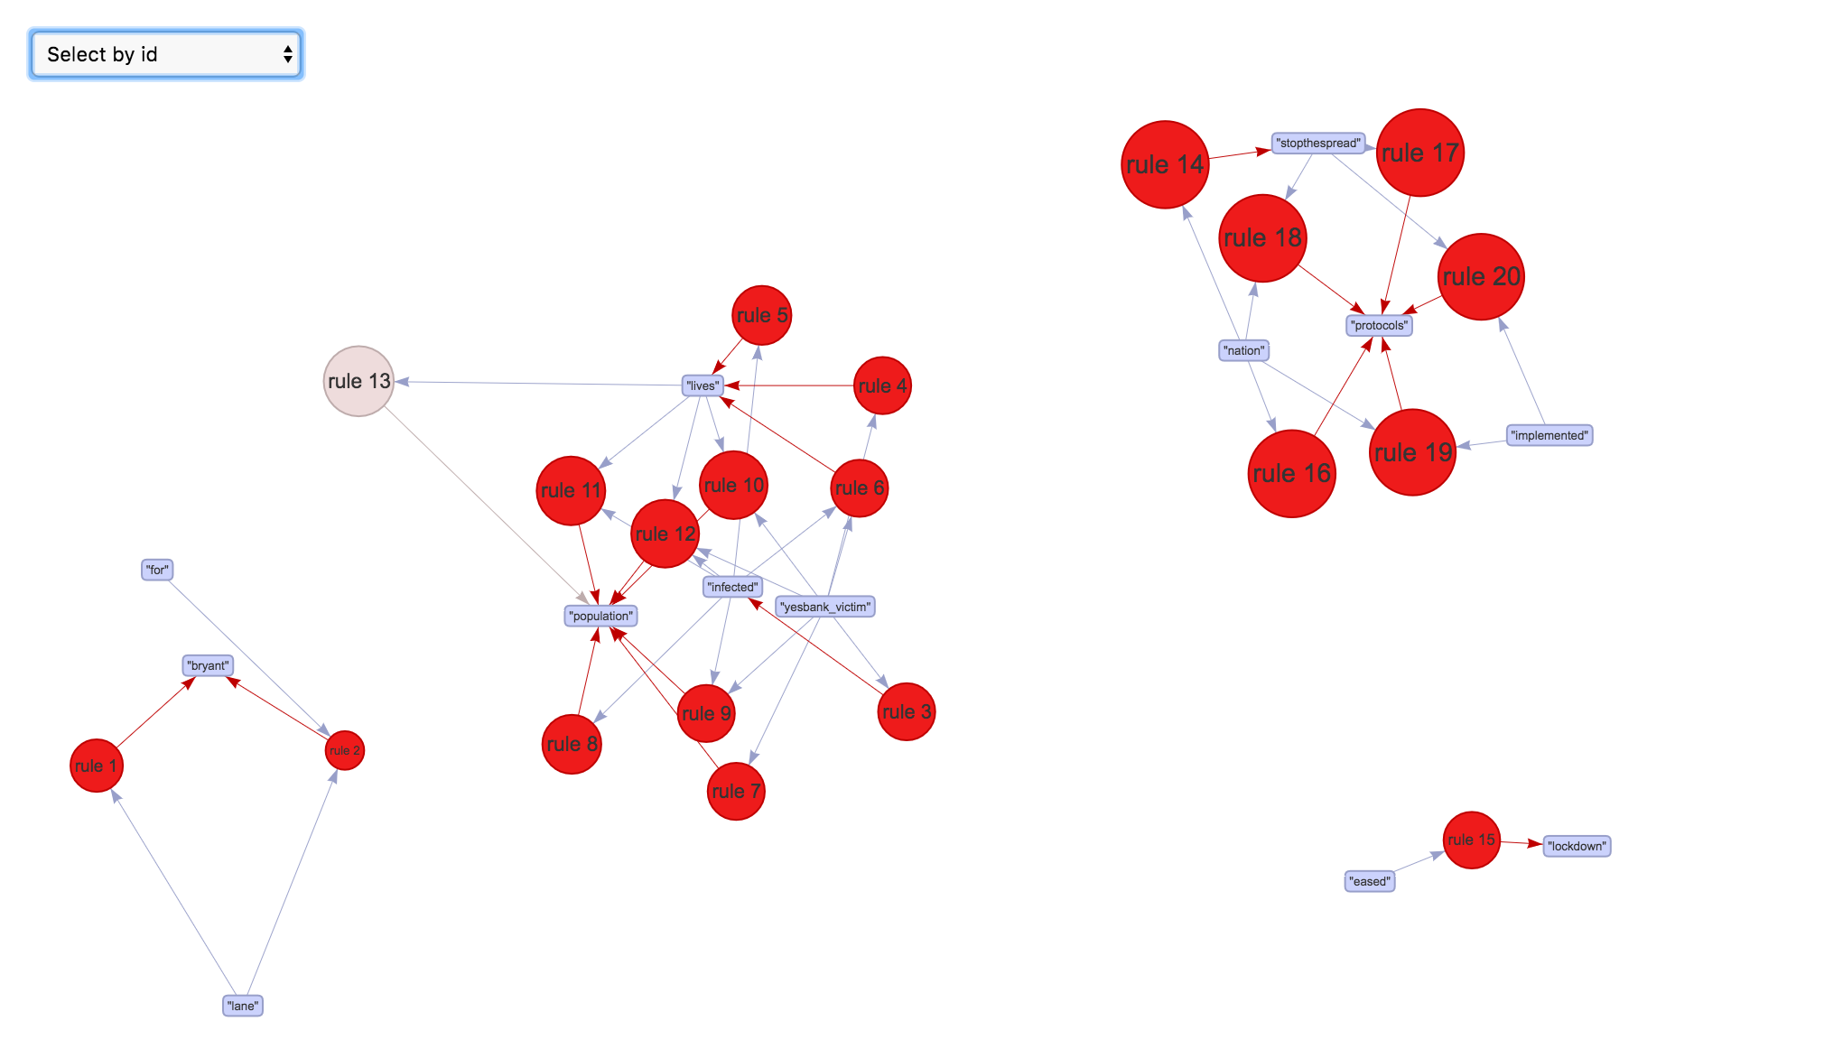

Below graph, shows details of rule10

RuleID : 10

itemset : {“lives”,”yesbank_victim”} => {“pouplation”} ( lhs and rhs values)

support: 0.0194

confidence: 1 (postive value)

lift: 46.8 ( > 1; suggests strong correlation)

count: 59 ( total number of occurances out of 3039 transactions)

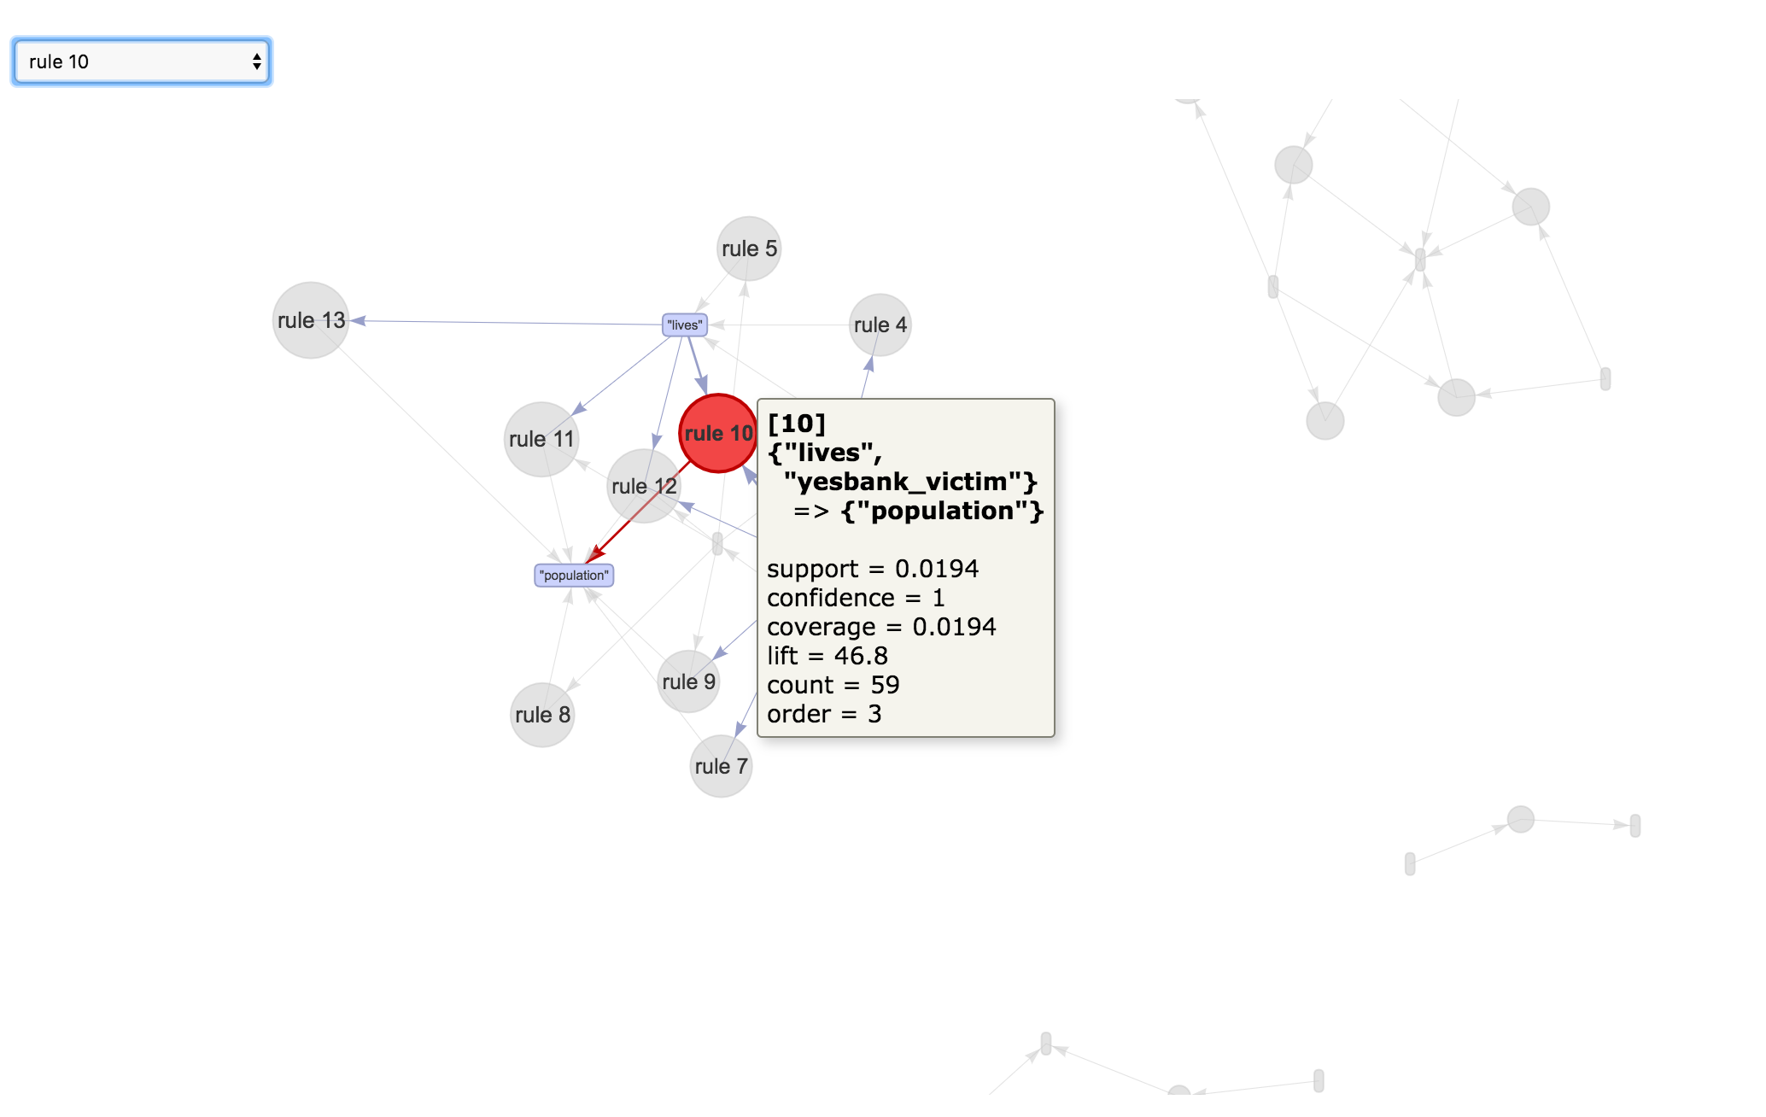

Below chart, only focuses on Itemset value “yesbank_victim”

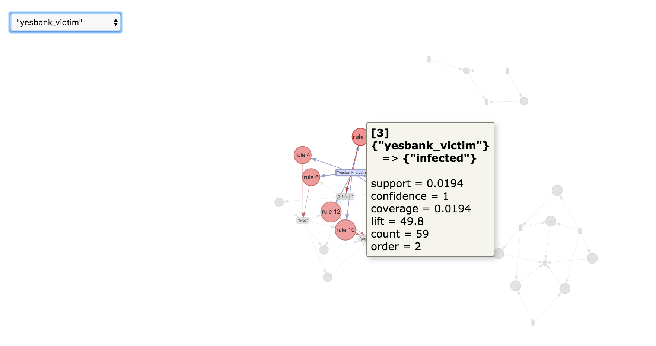

In addition, as discussed earlier, lets analyze other parameters for rules creation. While, keeping minsupport as 0.001 and maxsupport as 0.8 by incrementing 0.005, it shows that when the support value is above 0.02 then no rules meets the threshold. This is another reason pattern stopped after length 5 where the support value was going further low.

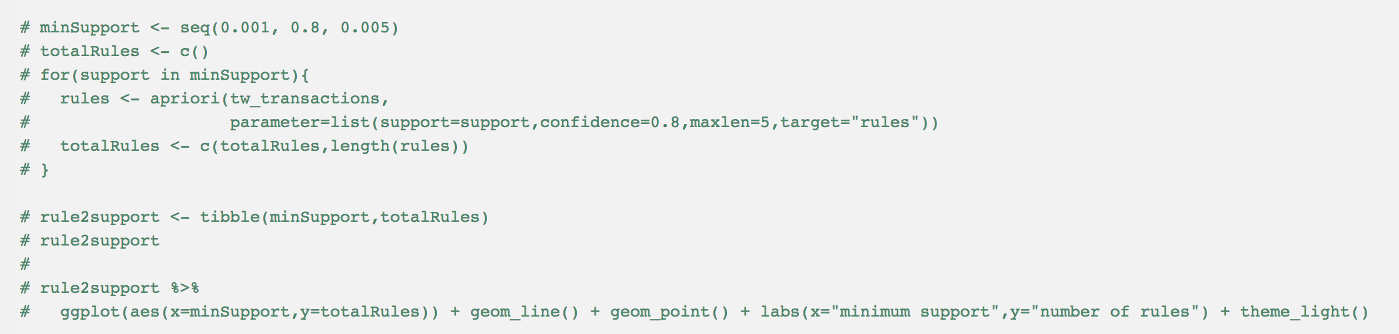

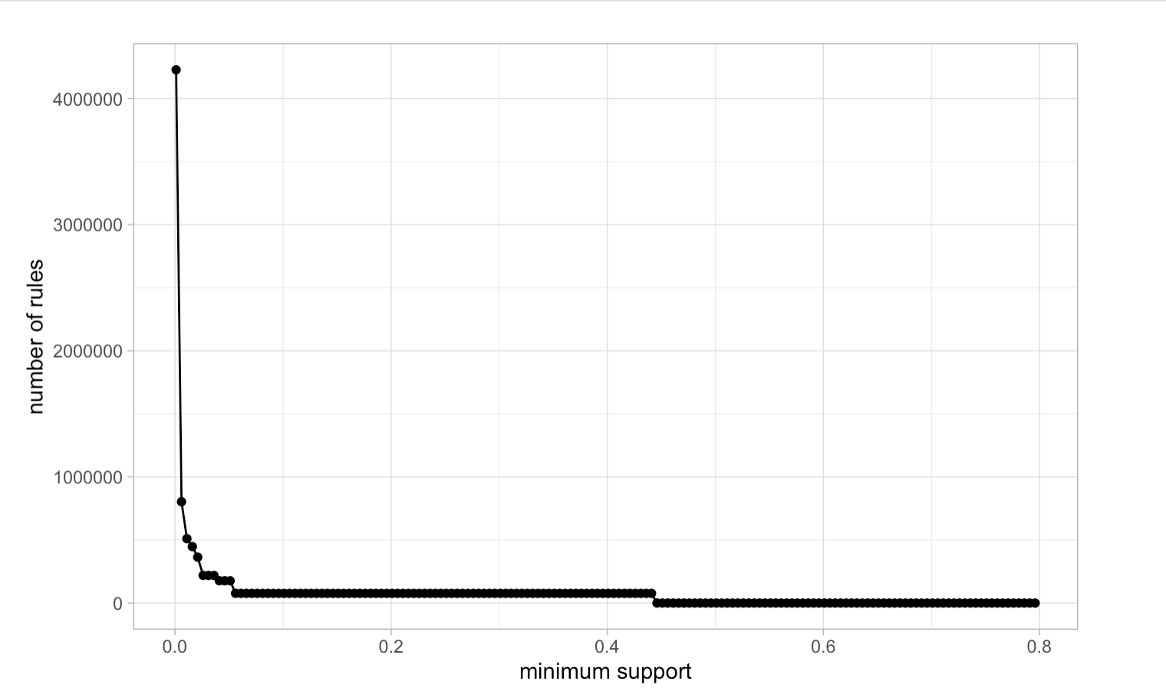

## **Other Visualizations**

Let’s explore twitter feeds further; starting with most frequent word. Clearly, retail, covid,19 and sales has been dominating the chart.

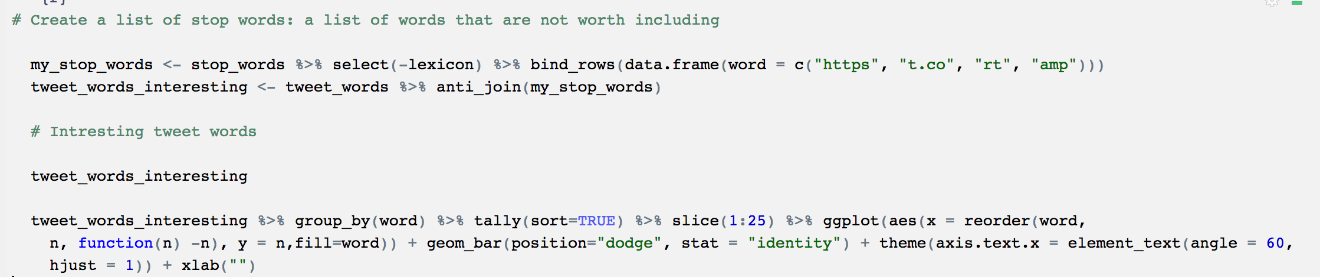

Frequency Chart

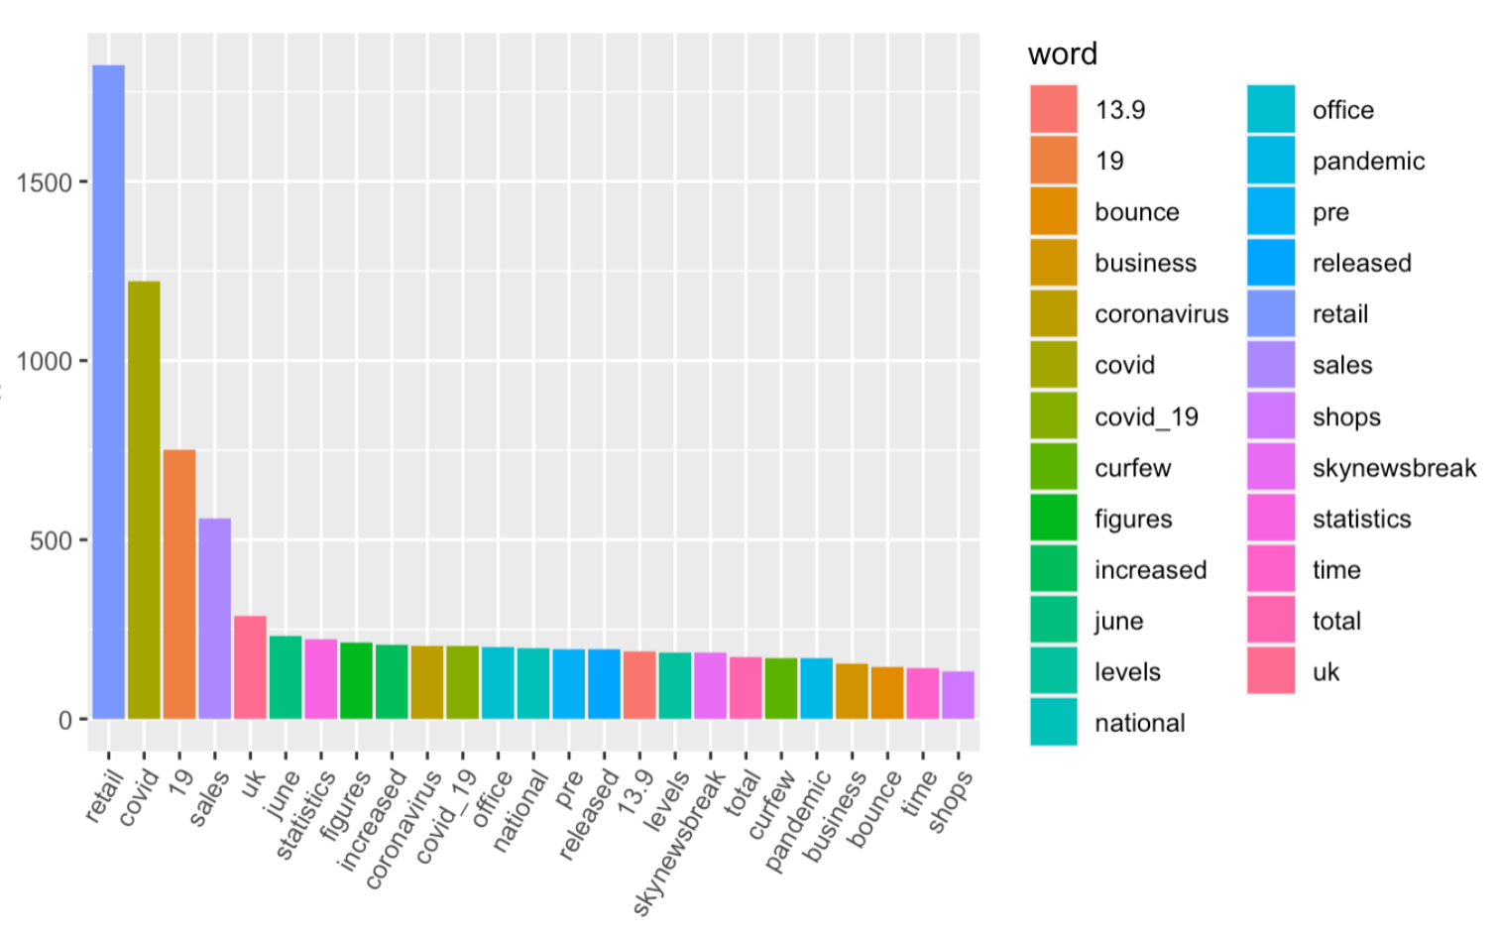

Sentimental analysis

Next, sentimental analysis on the dataset. Here, “nrc” lexicon categorizes tweet data in binary fashion (yes/no) on categories such as positive, negative, anger, anticipation, disgust, fear, joy, sadness, surprise, and trust.

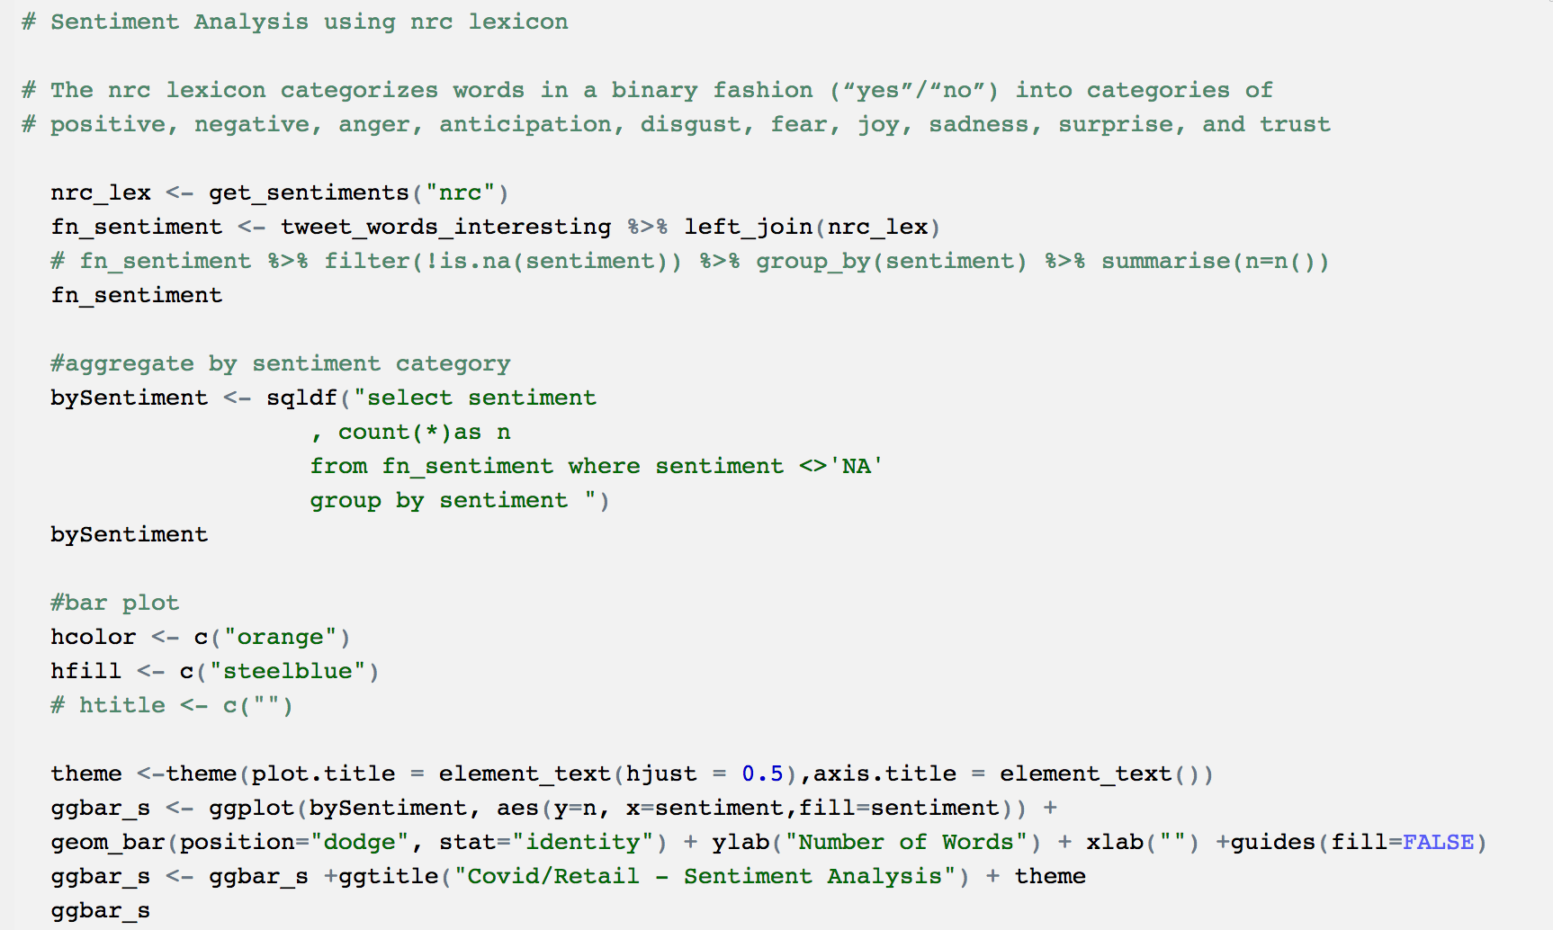

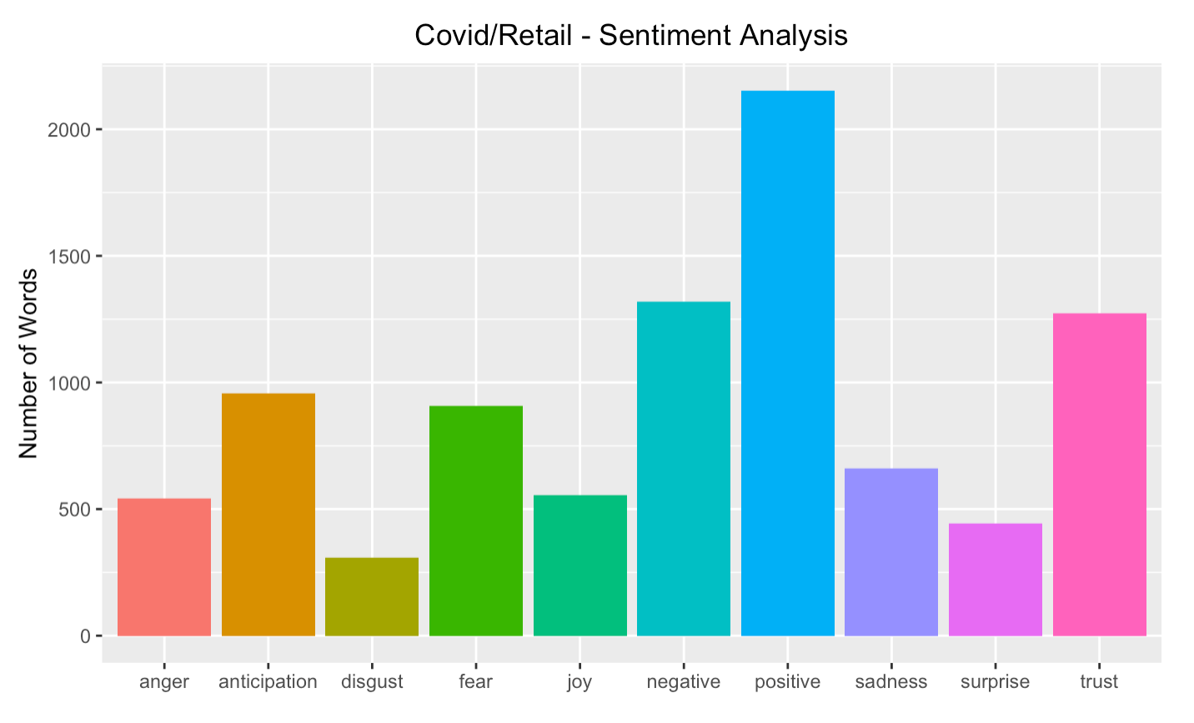

Even though, positive being the highest. However, combination of negative + anger+ anticipation +fear +disgust + sadness combinedly leads the chart inferring most the tweets were caring negative sentiment along.

Wordcloud

Lastly, a Wordcloud on twitter feeds to conclude the top 4 trending words had been retail, covid ,19 and Sales.

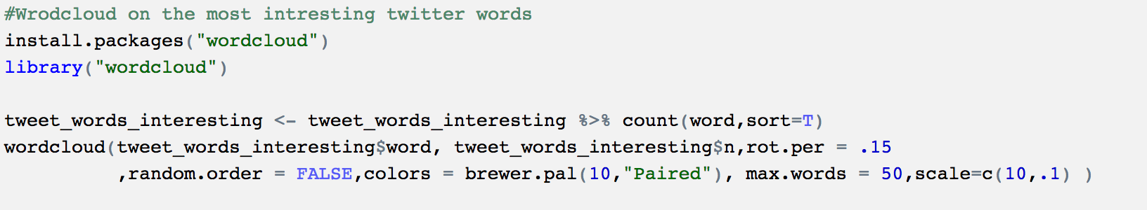

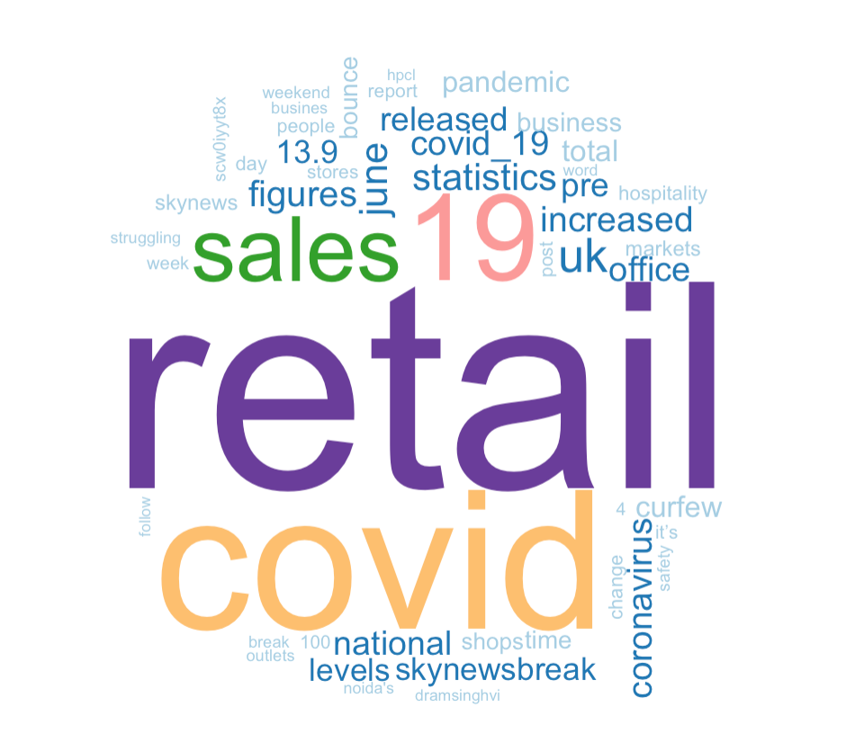

## **Summary**

After extracting data via Twitter API, following observations were made.

* Total number of transactions/rows/feeds imported using “covid+retail” keyword was **3039**.
* Most frequent words being “**retail**”, “**covid**”, “**19**” and “**sales**”
* Overall sentiment has been negative
* When the support value is assigned >**0.02**; there were no supporting threshold values on the itemset. So, the number of rules beyond this point has been successful.
* Baseline parameter used in the apriori rules generation is **support**: 0.0125; **confidence**:0.8 and **minlen**:2
* Top 20 rules as below; based on highest “Lift” value > **39.45**



* Data scrubbing, helped cleanup data type, stop words, strip through punctuations, update words to lowercase, replace NULL and empty values and words having digits in it.
* In addition, knowledge to explore twitter (unstructured) data using unsupervised algorithm (association rule mining). Having restriction on the API to pull more than ~3000 tweets, sets a limitation to deal with limited data. Also, It appears that often compute is heavy utilization running the rule confirming the need for better compute engine working with big data.

## **Glossary**

* **twitteR** package from R provides an easy way for accessing and searching Twitter APIs “bag of words” and an excellent source for association rule mining.
* Association Rule mining (**ARM**), help uncover hidden relationship between of set of elements from collection of distinct transactions. ARM implies chances of occurrence than causality. Market-basket analysis is the greatest example for ARM.
* An **itemset** is the list of all the items from the antecent-X {**lhs**} and the consequent-Y {**rhs**}
* **Support-** gives an idea how frequent an itemset is present in all the transactions. If an itemset has very low support, it implies that no confidence/conclusion can be made from the association rule.

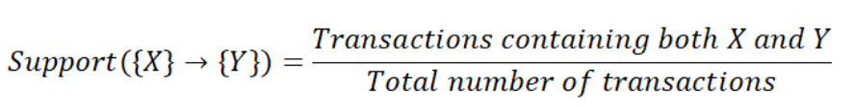

* **Confidence-** gives the likeliness of occurrence of consequent-Y {rhs} considering antecent-X {lhs} is already present. However, Highest confidence alone may not be sufficient as well in the association determination.

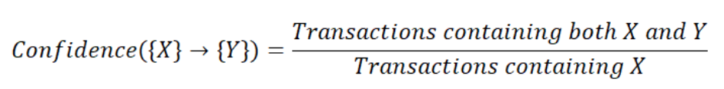

* **Lift-** gives an idea of the rise in probability of having consequent-Y {rhs} with the knowledge of antecent -X {lhs} being present over the probability of consequent-Y{rhs} without knowing the occurrence of antecent-X{lhs}.

